St Lucie County Fire District Evidence Briefing Packet
  - Documented inconsistencies omissions investigative routing and potential retaliation
Presented to | Office of the State Attorney, Nineteenth Judicial Circuit of Florida
Meeting date | September 22, 2026
Submitted by | Kevin S. Keene, Community Liaison
Evidence prepared by | Jordon Hutchinson
Source basis | Official public-record documents obtained from the St. Lucie County Fire District and related investigative materials
Purpose
This packet identifies a connected set of discrepancies in the handling, description, investigation, and reporting of employee complaints and disciplinary matters. It is submitted to assist the State Attorney in determining whether the underlying records warrant independent preservation, authentication, interview, subpoena, or investigative review.
Kevin S. Keene | 5255 Palmetto Ave | Fort Pierce Florida 34982
772-275-2040 | kevinkeene1961@gmail.com

Executive Summary
The exhibits collectively present more than isolated wording disputes. They identify a recurring pattern in which officials appear to have controlled complaints in which they were named, described investigative routes that were unavailable or inconsistently applied, supplied materially different accounts to investigators, and characterized source material in ways that may have omitted or expanded significant facts. The February 4 through February 9 sequence also raises a focused question about whether protected complaints were followed almost immediately by adverse disciplinary action.
The packet does not substitute the comparison graphics for the underlying records. Each comparison should be tested against the original email, complaint, interview notes, outside-counsel letter, investigative report, metadata, and distribution history. The requested review is therefore directed to the authenticity, completeness, chronology, intent, and use of the original records.

Principal Matters for Review
- Whether a named respondent personally controlled, closed, or redirected complaints alleging misconduct against himself and other senior officials.
- Whether complainants were directed to an Office of Internal Affairs that Chief Lee later stated did not exist.
- Whether descriptions supplied to the Fire Board, Civil Service Appeals Board, or outside investigators added findings not contained in the cited source document.
- Whether significant eyewitness information, threat allegations, Union objections, or identified witnesses were omitted or minimized in investigative summaries.
- Whether materially conflicting accounts were knowingly supplied to investigators regarding complaints, employee treatment, Board knowledge, and investigative procedures.
- Whether the February 9 Loudermill notice was causally connected to, or retaliatory for, the February 4 complaint and February 6 demand for an independent process.
- Whether public statements that the Board was uninvolved are consistent with interview notes indicating the Board was kept informed and discussed proposed handling.

Requested Investigative Actions
- Preserve and obtain native-format copies of all cited emails, attachments, complaints, interview notes, reports, letters, draft reports, metadata, distribution lists, and revision histories.
- Obtain the complete Jackson Lewis investigative file, including notes, recordings, transcripts, drafts, communications, scope instructions, and materials supplied by District officials.
- Interview Jordon Hutchinson regarding the source documents, the preparation of these comparisons, and the location of the original records.
- Interview the officials and witnesses identified in the exhibits separately and compare their statements against contemporaneous records.
- Determine who authorized each investigative routing decision, record characterization, report omission, Board communication, and disciplinary action.

Chronology of Key Events
Date or period | Event reflected in supplied comparisons
September 19 2025 | Chief Lee reportedly cautioned against taking an individual complaint directly to the Fire Board, while stating the Board becomes involved when a matter directly concerns him as a contract employee.
September 23 2025 | Chief Lee acknowledged receipt of the complaint packet, told complainants the Board was not an appeal body, and told the Board the issues were fully addressed administratively and did not require Board involvement.
September 24 2025 | Chief Lee closed the matter and directed future allegations to the Office of Internal Affairs.
January 24 2026 | Chief Lee emailed the Board a characterization of Attorney Gainey’s assessment that allegedly included findings not stated in Gainey’s cited letter.
February 4 2026 | A formal administrative complaint named Chief Lee, Assistant Chief Gonzalez, and District Attorney Kim Sabol as respondents.
February 5 2026 | Chief Lee declined further internal investigative action and stated no Board action was requested or required.
February 6 2026 | Complainants requested identification of an independent process, asked whether their claims were being investigated, and requested protection.
February 9 2026 | The District issued a Loudermill notice contemplating discipline up to termination for alleged procedural misconduct and routing violations.
March 24 and 30 2026 | Attorney Gainey’s and Chief Lee’s accounts reportedly differed regarding whether a cultural assessment was part of the original assignment.
Jackson Lewis interviews | Interview notes reflected additional disputes regarding Union objections, employee treatment, Board knowledge, omitted witnesses, and the availability of an Office of Internal Affairs.

Issue and Evidence Matrix
Issue | Record comparison presented | Ref
Complaint routing and independence | Prior practice described as an independent handoff; later complaint was controlled and closed internally; future matters were directed to an OIA Lee later said did not exist. | Exhibit 1
Complaint followed by discipline | Named respondent declined investigation; complainants sought an independent route; Loudermill notice followed within days. | Exhibit 2
Board awareness | Lee, Gonzalez, and Sabol interview notes reportedly indicate Board awareness and discussion despite other statements limiting Board involvement. | Exhibit 3
Scope of outside counsel work | Lee and Gainey reportedly supplied different accounts of whether a cultural assessment was an original purpose or a later opinion. | Exhibit 4
Expansion of cited findings | Lee’s January 24 characterization allegedly added intimidation, resistance to accountability, and pressure language absent from Gainey’s letter. | Exhibit 5
Omitted Union objections | Gonzalez reportedly said the Union had no problem with the investigation; Meyer and Sapp notes record multiple objections. | Exhibit 6
Minimized eyewitness account | Lee’s summary described a car-fire statement; Fanelli’s email described a physical shoulder bump and other allegations were reportedly omitted. | Exhibit 7
Conflicting account concerning Jonas | Lee and Gonzalez reportedly differed about animosity, complaints, involvement, and whether Jonas was interviewed. | Exhibit 8
Prejudgment and disparagement | Interview notes contain statements concerning splitting employees up, promotion judgments, and “get the head of the snake.” | Exhibit 9

Source Attribution and Handling
The attached comparison graphics were prepared by Jordon Hutchinson from official public-record documents obtained during the SLCFD matter. The graphics reproduce selected quotations and provide Hutchinson’s explanatory interpretation. For evidentiary use, each quotation and characterization should be matched to its original record, and the original record should be authenticated through the producing custodian or a competent witness.
The images are included intact as supplied. Their inclusion preserves the preparer’s presentation; it does not alter the need to obtain the complete underlying records, including surrounding context, attachments, drafts, metadata, and distribution history.

Exhibit 1
Complaint routing and nonexistent Office of Internal Affairs
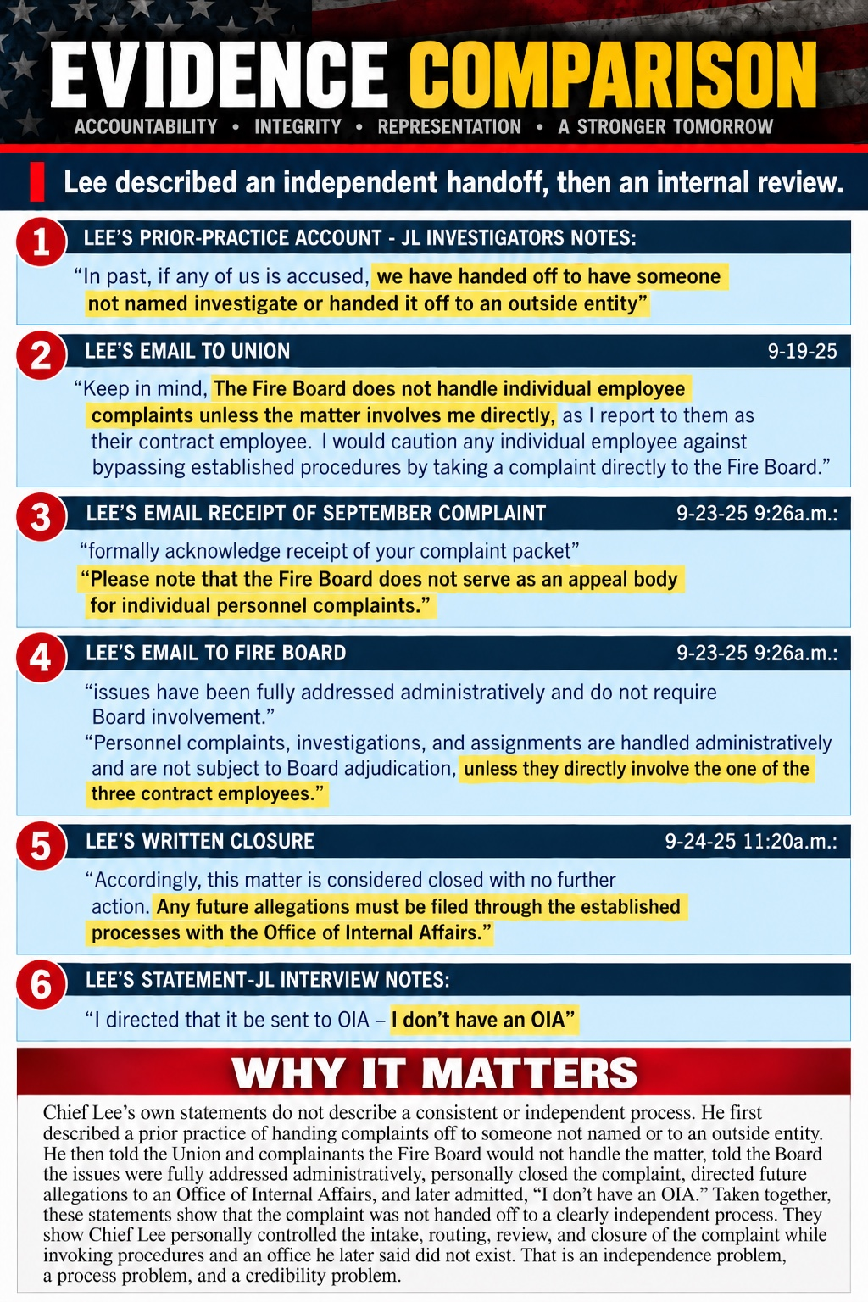
Comparison graphic prepared by Jordon Hutchinson from obtained official public-record documents. Review against the complete underlying records.

Exhibit 2
February 4 complaint and February 9 Loudermill notice
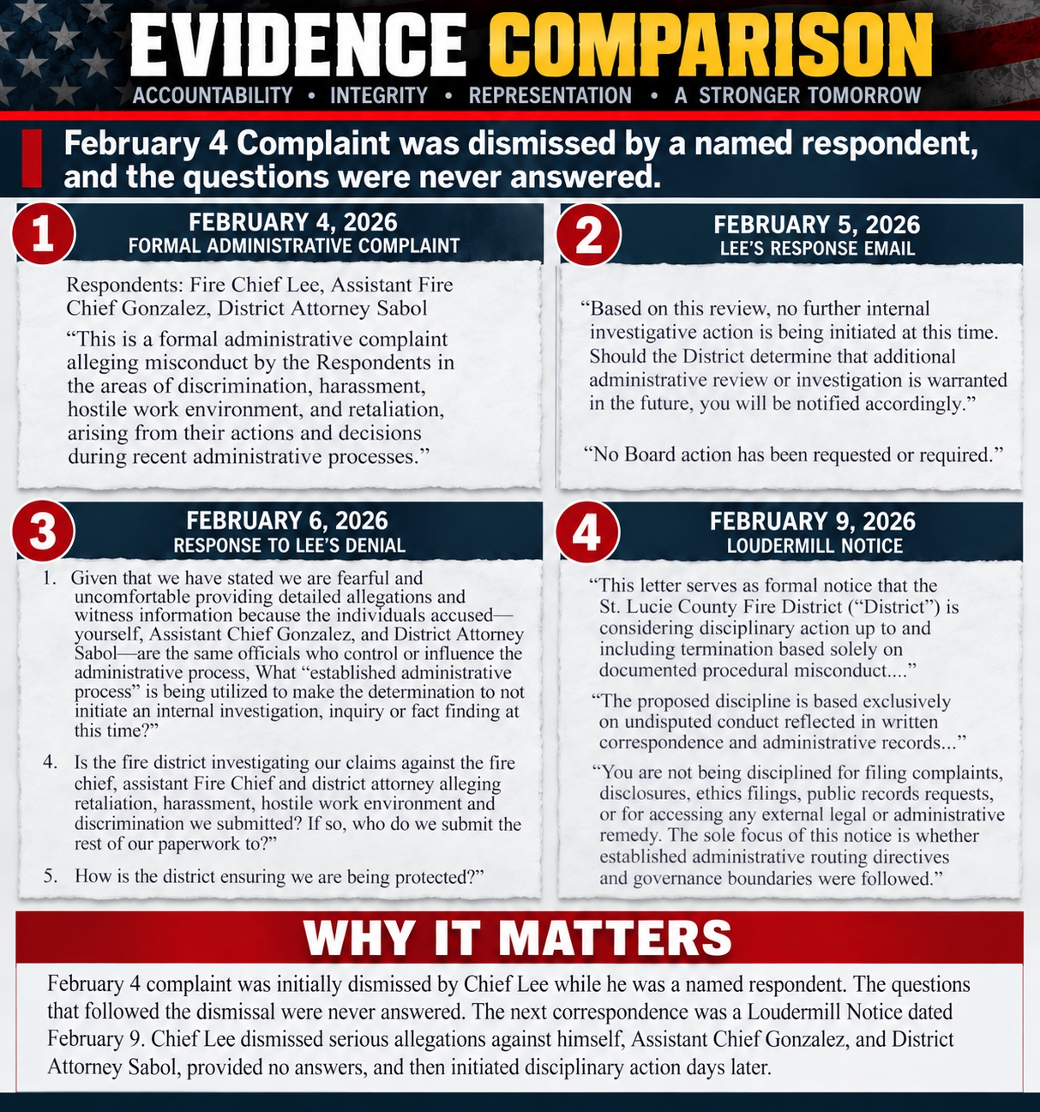
Comparison graphic prepared by Jordon Hutchinson from obtained official public-record documents. Review against the complete underlying records.

Exhibit 3
Fire Board awareness and communications
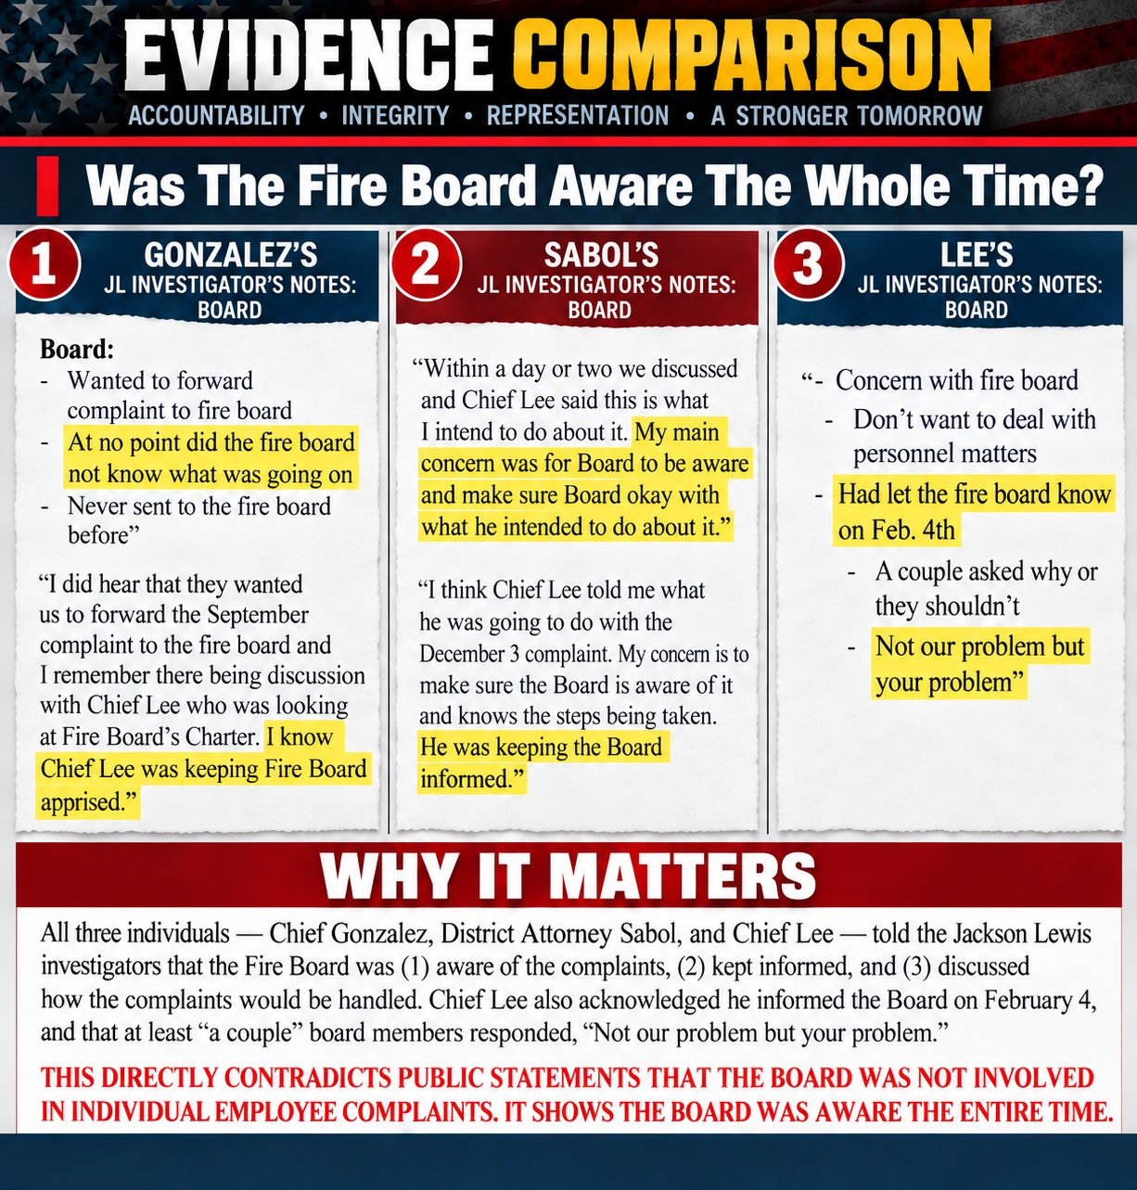
Comparison graphic prepared by Jordon Hutchinson from obtained official public-record documents. Review against the complete underlying records.

Exhibit 4
Conflicting descriptions of Gainey’s role
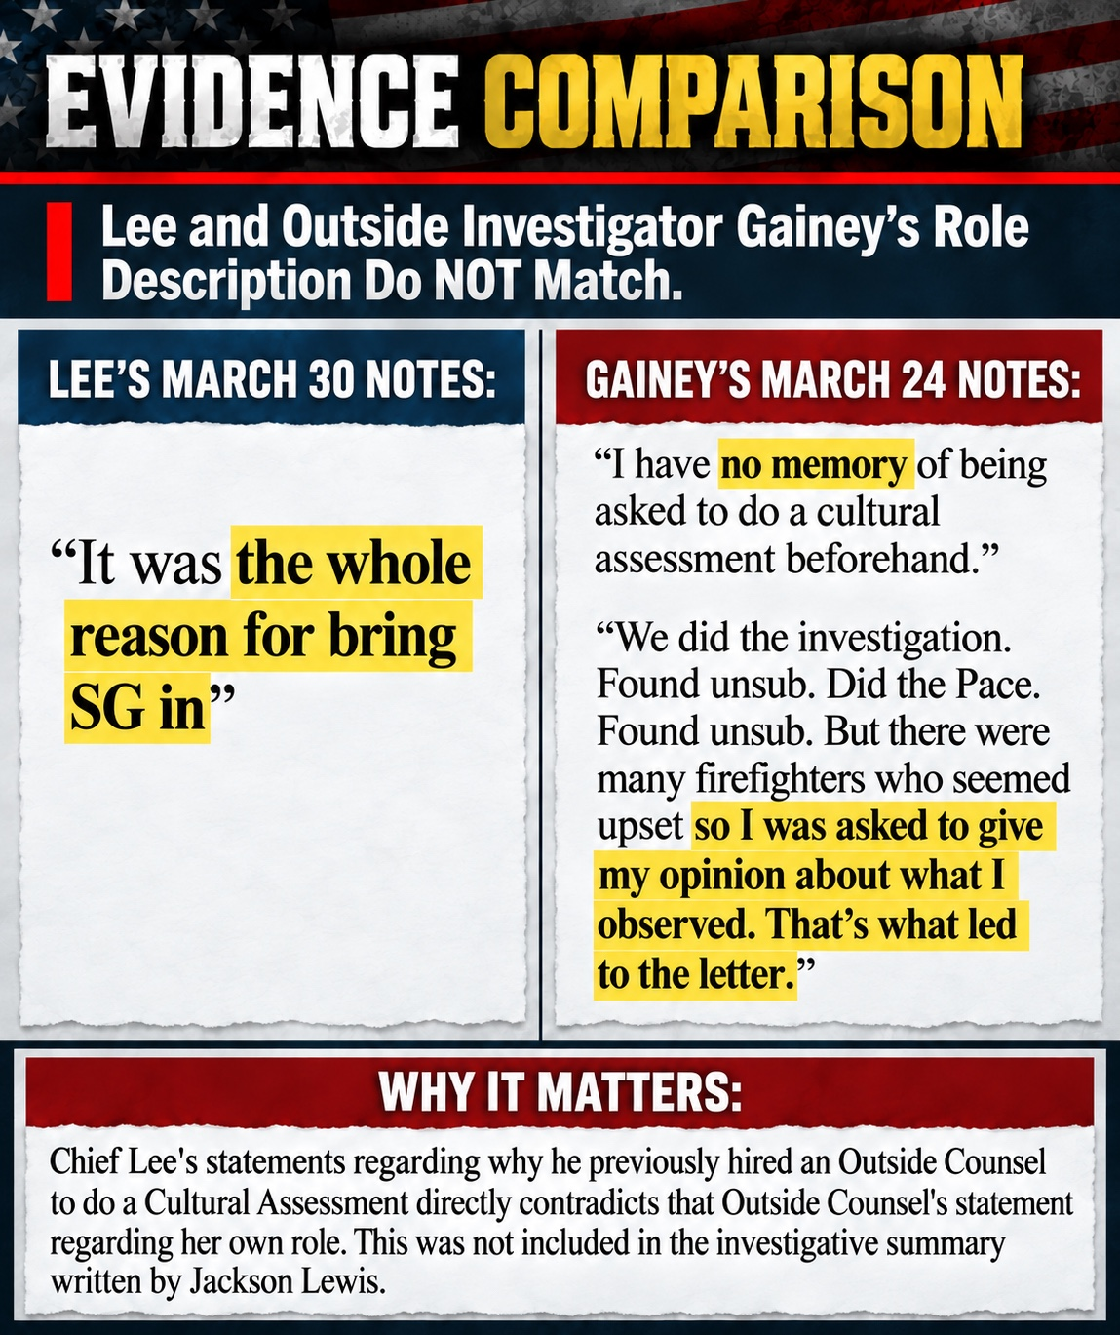
Comparison graphic prepared by Jordon Hutchinson from obtained official public-record documents. Review against the complete underlying records.

Exhibit 5
January 24 characterization compared with Gainey’s letter
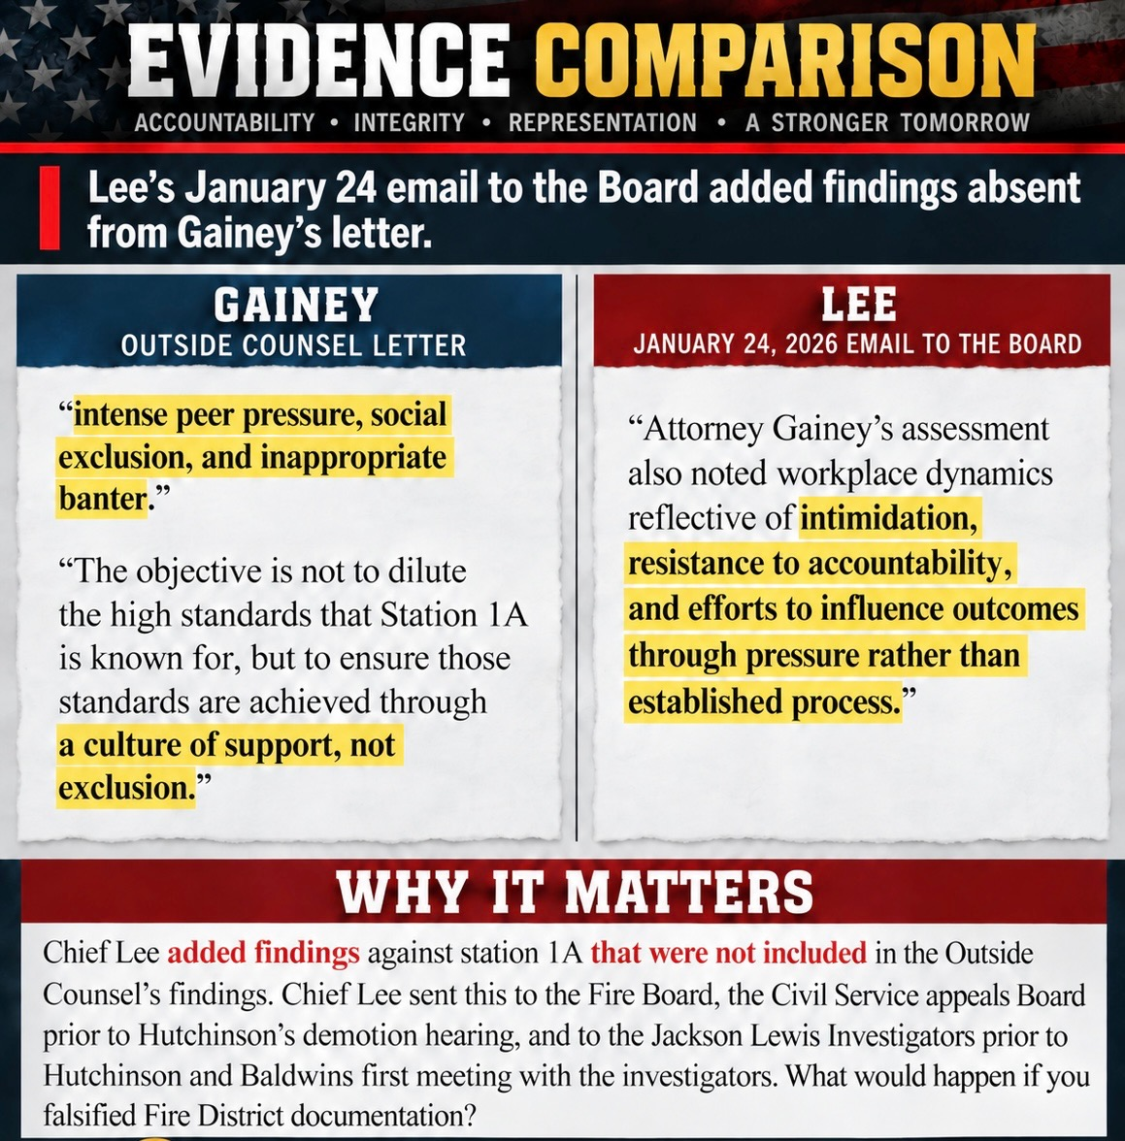
Comparison graphic prepared by Jordon Hutchinson from obtained official public-record documents. Review against the complete underlying records.

Exhibit 6
Union objections omitted from the Jackson Lewis summary
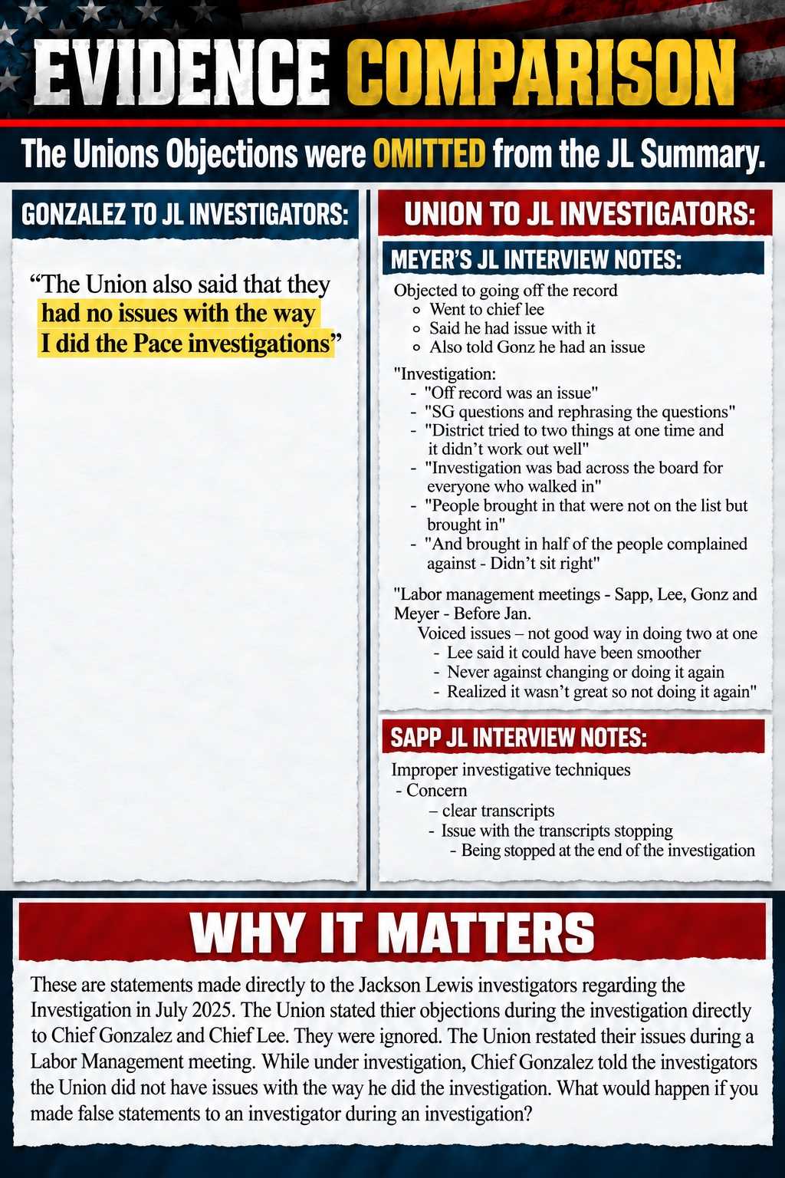
Comparison graphic prepared by Jordon Hutchinson from obtained official public-record documents. Review against the complete underlying records.

Exhibit 7
Fanelli email and the characterization of omitted facts
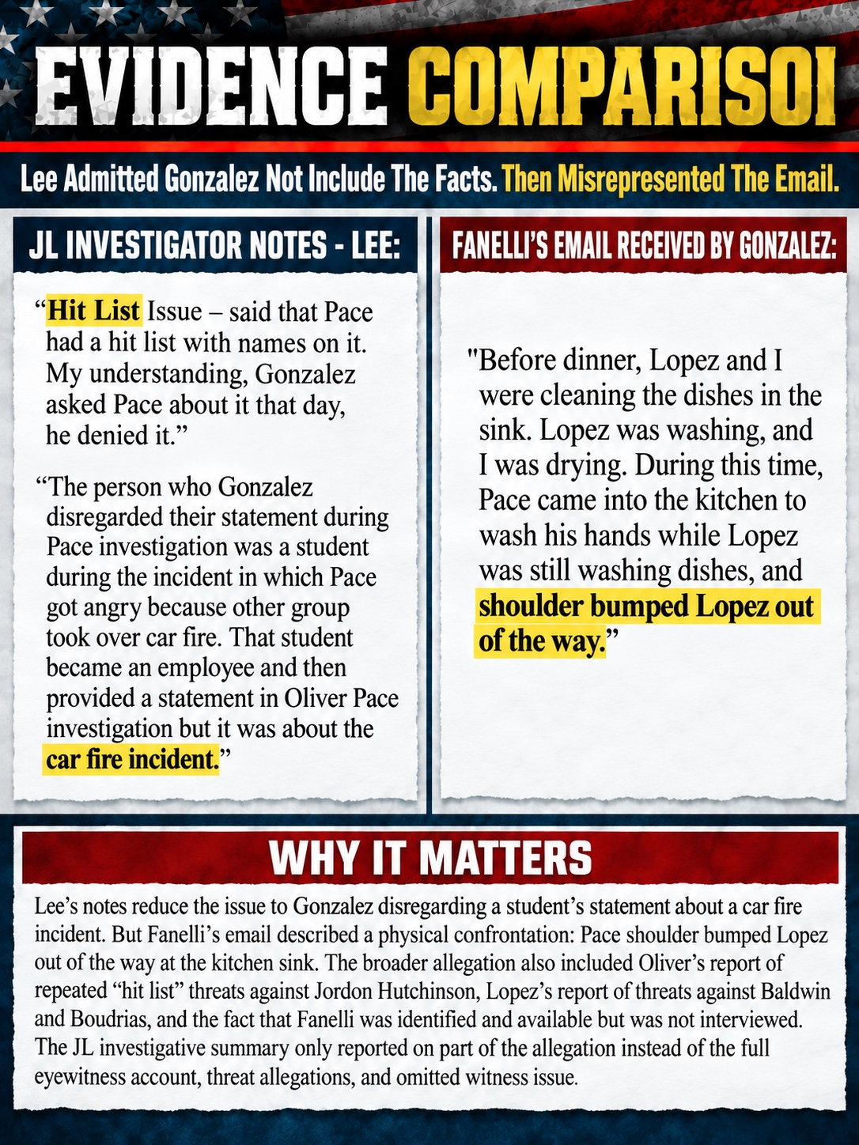
Comparison graphic prepared by Jordon Hutchinson from obtained official public-record documents. Review against the complete underlying records.

Exhibit 8
Conflicting accounts concerning Jonas
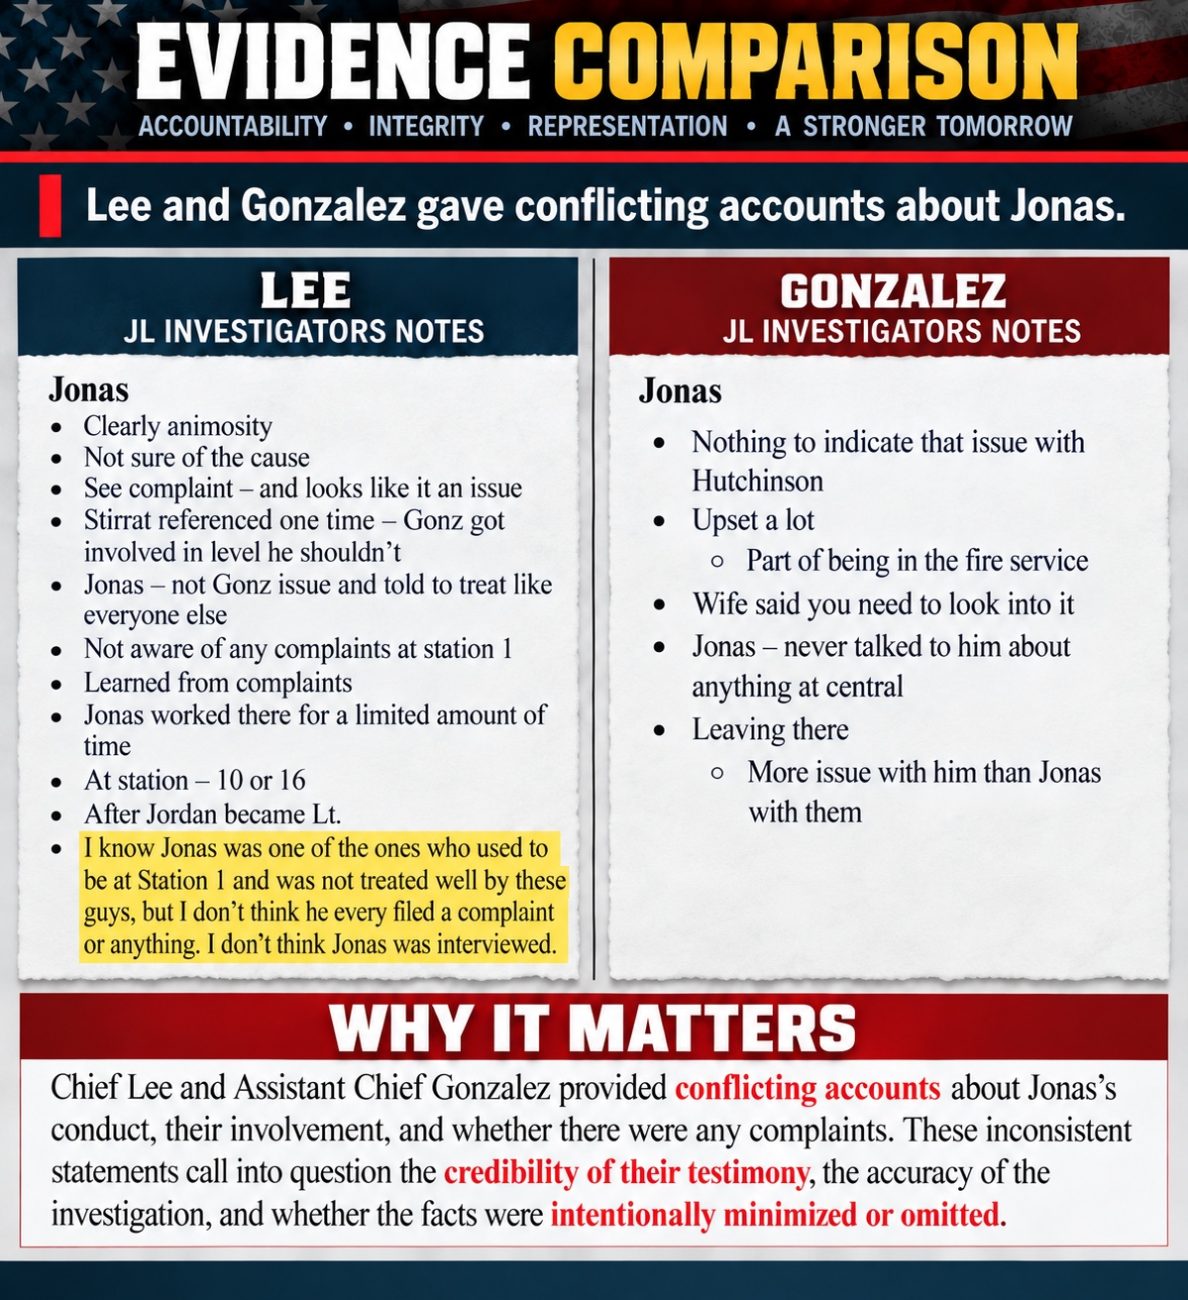
Comparison graphic prepared by Jordon Hutchinson from obtained official public-record documents. Review against the complete underlying records.

Exhibit 9
Prejudgmental and disparaging statements reflected in interview notes
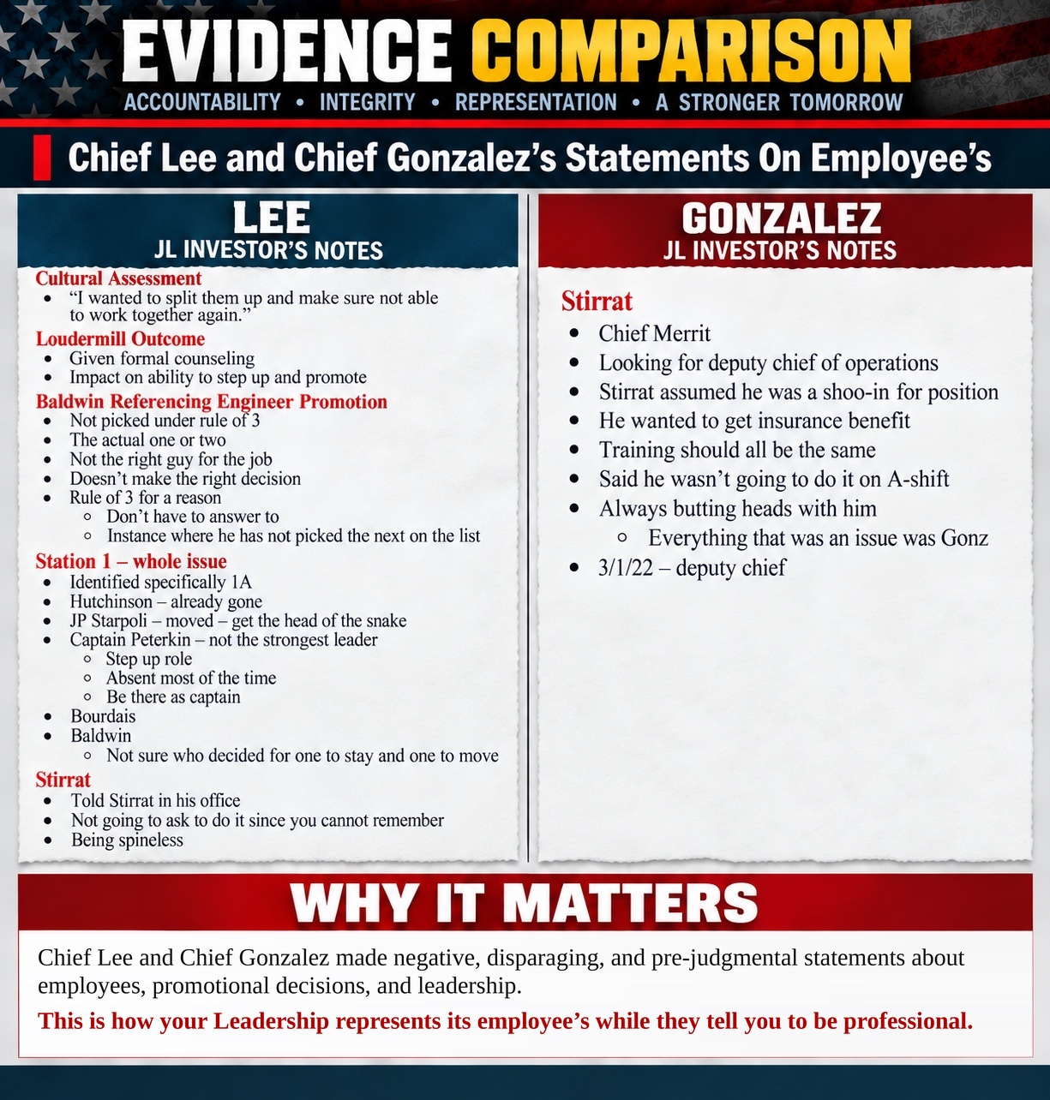
Comparison graphic prepared by Jordon Hutchinson from obtained official public-record documents. Review against the complete underlying records.

Submission and Follow Up
I respectfully request that the Office of the State Attorney evaluate the underlying records and determine whether an independent inquiry is warranted. I am prepared to provide the original public-record productions in my possession, identify witnesses, and assist in locating the documents referenced in these exhibits.
________________________________________
Kevin S. Keene
Community Liaison
Date: ____________________

Materials to Bring or Transmit Separately
- Native copies of the emails and attachments quoted in the exhibits.
- The February 4 complaint, February 5 response, February 6 response, and February 9 Loudermill notice.
- Attorney Gainey’s complete letter and related engagement and scope records.
- Complete Jackson Lewis interview notes, recordings, transcripts, report, drafts, and supporting materials.
- Records showing who received Chief Lee’s January 24 communication and when.
- The complete Fire Board communications referenced in the interview notes.

